UNIVERSITY OF NEVADA LAS VEGAS – DEPARTMENT OF ELECTRICAL AND COMPUTER ENGINEERING



Design Assignment 6

CPE 301 Fall 2016

Luis Ruiz

**PART 0**

The assignment took me about 1 hours to do.

1. **PART A: Description**

My design consists of a C program that reads in a value from a potentiometer and outputs on to the screen using UART. The program takes advantage of Analog to Digital converter to read a voltage off a potentiometer that is creating a voltage divider with a resistor. The value being read is consistently fluctuating from 0 – 5 V max, depending on the restive state of the potentiometer. The value of the resistor is 330 ohms as for the potentiometer, it has a max value of 2000 ohms. The output will be via PUTTY using UART using asynchronous communication. Note a delay of 1 second is placed for more readability, since it is a string is consistently being outputted.

**PART B: Code**

**Header File ioe.h**

#include <avr/io.h>

#ifndef IOE_H

#define IOE_H

#ifndef FREQ

#define FREQ 16000000UL

#endif

/*SETTINGS*/

#define BAUDRATE 9600 //BAUDRATE (9600 is default)

#define BUFF 256

#define ASYNCH_NORM (FREQ/16/BAUDRATE - 1)

#define ASYNCH_DUB (FREQ/8/BAUDRATE - 1)

#define SYNC_MASTER (FREQ/2/BAUDRATE - 1)

/*MACROS USEFUL TO DISABLE AND ENABLE*/

#define TX_START() UCSR0B |= _BV(TXEN0) // Enable TX

#define TX_STOP() UCSR0B &= ~_BV(TXEN0) // Disable TX

#define RX_START() UCSR0B |= _BV(RXEN0) // Enable RX

#define RX_STOP() UCSR0B &= ~_BV(RXEN0) // Disable RX

#define COMM_START() TX_START(); RX_START() // Enable communicationsF

#define COMM_STOP() TX_STOP();RX_STOP() // Disable Communication

//Frame Size to be Transmitted

#define CHAR6() UCSR0C |= _BV(UCSZ00)

#define CHAR7() UCSR0C |= _BV(UCSZ01)

#define CHAR8() UCSR0C |= _BV(UCSZ01)|_BV(UCSZ00)

#define CHAR9() UCSR0B |= _BV(UCSZ02);UCSR0C |= _BV(UCSZ01)|_BV(UCSZ00)

/* Interrupt macros; Remember to set the GIE bit in SREG before using (see datasheet) */

#define RX_INTEN() UCSR0B |= _BV(RXCIE0) // Enable interrupt on RX complete

#define RX_INTDIS() UCSR0B &= ~_BV(RXCIE0) // Disable RX interrupt

#define TX_INTEN() UCSR0B |= _BV(TXCIE0) // Enable interrupt on TX complete

#define TX_INTDIS() UCSR0B &= ~_BV(TXCIE0) // Disable TX interrupt

/*Stop Bit*/

#define STOPBIT_1() UCSR0C &= ~(1<<USBS0)

#define STOPBIT_2() UCSR0C |= (1<<USBS0)

/*Parity Mode*/

#define DisParity() UCSR0C &= ~(1<<UPM01);UCSR0C &= ~(1<<UPM00)

#define EvenParity() UCSR0C |= (1<<UPM01)

#define OddParity() UCSR0C |= (1<<UPM01)|(1<<UPM00)

/*MODE*/

#define ASYNCH_MODE() UCSR0C &= ~(1<<UMSEL01);UCSR0C &= ~(1<<UMSEL00)

#define SYNCH_MODE() UCSR0C |= (1<<UMSEL00)

#define MASTER_MODE() UCSR0C |= (1<<UMSEL01)|(1<<UMSEL00)

/*Enable Interrupts*/

#define recInterrupt UCSR0B |= (1 << RXCIE0)

/*FUNCTION DECLERATION*/

/*

* Procedure to initialize USART0 asynchronous with enabled RX/TX, 8 bit data,

* no parity, and 1 stop bit.

*/

void usart0_init_ ();

// Return a char from the serial buffer

/* Use this function if the RX interrupt is not enabled.

* Returns 0 on empty buffer

*/

unsigned char getChar_(void);

//Transmits a byte

/*

* Use this function if the TX interrupt is not enabled.

* Blocks the serial port while TX completes

*/

void putChar_(unsigned char data);

/*A string print called printm that uses a

char array and your putchar clone to transmit

strings*/

void printm(unsigned char *str);

/*uses an uninitialized char array and your getchar clone to

construct a string for your ATmega328P */

//const unsigned char* scanm(void);

#endif /*IOE_H*/

**Main.c**

/*

* Author : Luis

*/

#include <avr/io.h>

#include "ioe.h"

#include <util/delay.h>

#include <stdio.h>

#define *F_CPU* 16000000UL

/*

* Procedure to initialize USART0 asynchronous with enabled RX/TX, 8 bit data,

* no parity, and 1 stop bit.

*/

void usart0_init_ ()

{

// To set baud rate

UBRR0H = ((ASYNCH_NORM) >> 8); //top nibble

UBRR0L = (*uint8_t*) ((ASYNCH_NORM)) ; //lower byte

COMM_START(); // enable transmit/receive

// asynchronous, 8N1, disable parity, 1 stop bit

ASYNCH_MODE();

DisParity();

STOPBIT_1();

CHAR8();

}

// Return a char from the serial buffer

/* Use this function if the RX interrupt is not enabled.

* Returns 0 on empty buffer

*/

unsigned char getChar_(void)

{

//Check if something was received and then

//return the item

while(!(UCSR0A & _BV(RXC0)));

return (unsigned char) UDR0;

}

//Transmits a byte

/*

* Use this function if the TX interrupt is not enabled.

* Blocks the serial port while TX completes

*/

void putChar_(unsigned char data)

{

//What until the buffer is empty

while(!(UCSR0A & _BV(UDRE0)));

UDR0 = (unsigned char)data;

}

/*A string print called printm that uses a

char array and your putchar clone to transmit

strings*/

void printm(unsigned char *str)

{

//While it's not NULL

while(*str != '\0')

{

putChar_(*str);

++str;

}

}

/*uses an uninitialized char array and your getchar clone to

construct a string for your ATmega328P */

const unsigned char* scanm(void)

{

//Allocate buffer of size 256

//and a ptr to it

unsigned char buff[BUFF] = {0};

unsigned char* ptr;

ptr = buff;

while((*ptr = getChar_())){

if(*ptr == '\n'|| *ptr == '\0' )break;

putChar_(ptr);

++ptr;

}

return buff;

}

void ADC0init()

{

DDRC &= ~(0<<DDC0); // SET PC.0 as an input

ADCSRA = 0x87; // Enable ADC and CLK/128

ADMUX = (1<<REFS0); // VCC reference, ADC0 single ended input

}

double Convert(double val)

{

return (((val*5.0)/1024.0));

}

void main()

{

char str[30];

double val;

unsigned int prev;

usart0_init_();

ADC0init();

while(1)

{

//Start conversion

ADCSRA |= (1 << ADSC);

//wait conversion to finish

while((ADCSRA & (1 << ADIF)) == 0);

//Get value that was converted

if(!((unsigned int)ADC == prev)){

prev = ADC;

val = Convert(prev);

*dtostrf*(val,1,3,str);

printm("Voltage Read: ");

printm(str);

putChar_('\n');

putChar_('\r');

*_delay_ms*(1000);

}

}

}

**PART C:Flow Chart**

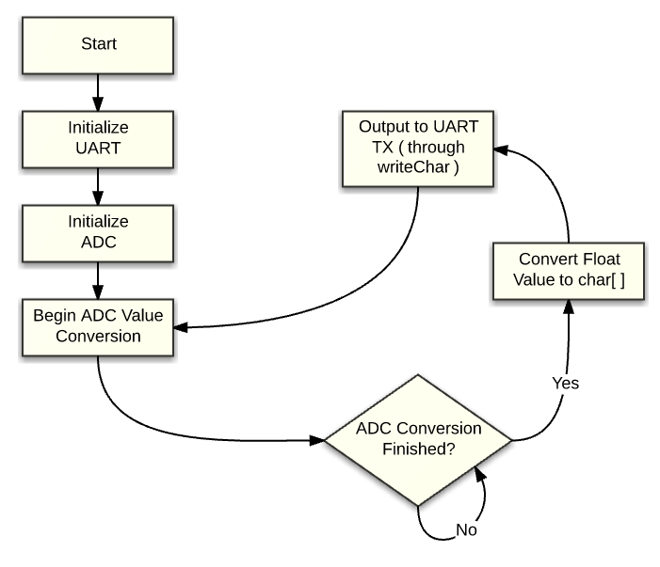

**PART D: Schematic**

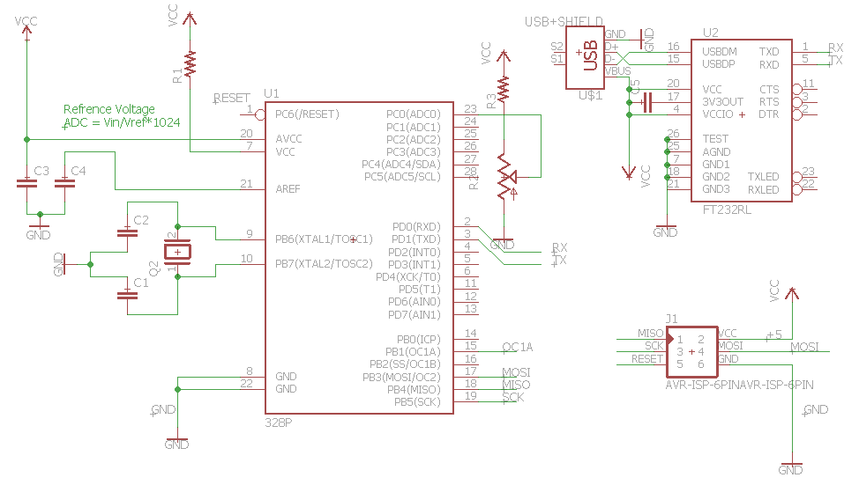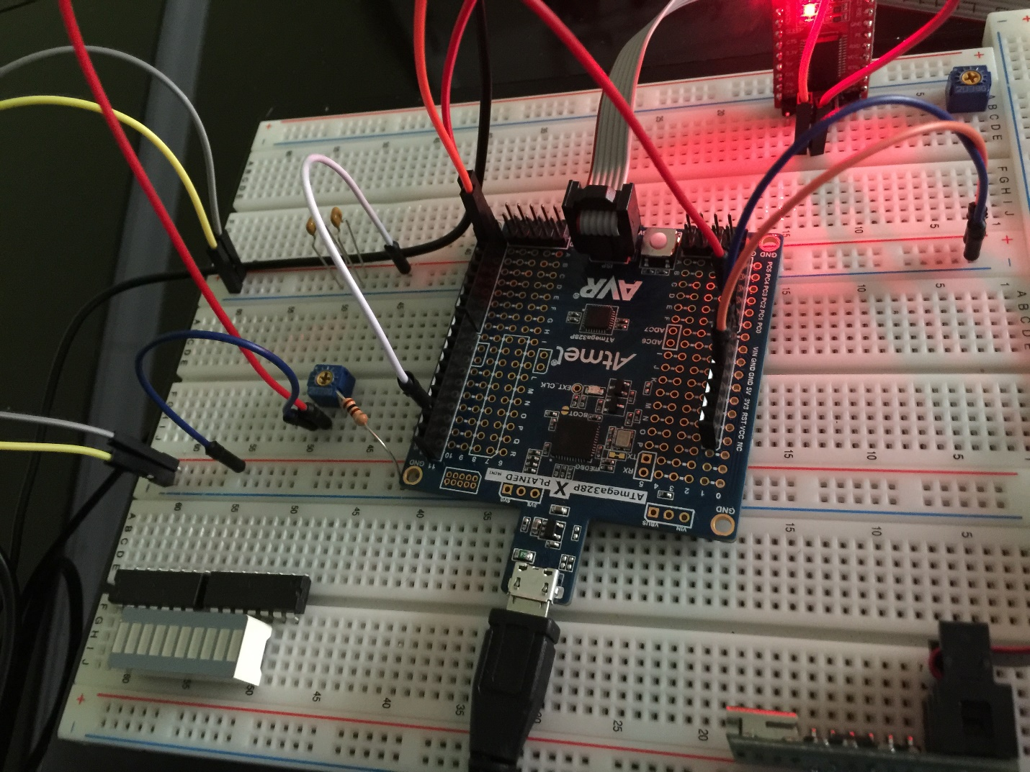

**PART E: Video**URL Video of Design Assignment 6: <https://youtu.be/Q0ZNh5p4kQE>